PART 2: Predictive Analyses

(Dataset: clean_matches.csv)
Key Predictive Analytics Questions Addressed:

- Toss Impact: How does the toss decision affect the probability of a win and the margin of victory?

- Win Margin Prediction: What is the relationship between toss decisions, venue, and match win margins (in runs or wickets)?

- Venue & Geographic Influence: Which venues (and cities) are associated with high-performance or close matches? Can we predict which venues are likely to produce competitive games?

- Seasonal Team Performance Forecasting: How do teams perform over time, and can we forecast future wins or predict changes in performance trends?

Four Predictive sets & dashboards:

DASHBOARD 1: Toss Decision Impact on Match Outcome

(Predictive Relationship: Toss decision → Win probability & win margin)

Analytical Approach:

Model Used: Logistic Regression (or classification tree) to predict the probability that a toss-winning team wins the match based on its toss decision (bat or field) with trend line.

Variables:

Input: “toss decision” (categorical: bat/field)

Output: “Toss Win outcome “(calculated field as a comparison of toss winner and winner), plus win margin variable (win by run)

- Created Sheet 1: Toss Decision Frequency & Win Outcome

- Took ‘toss decision’ to columns.
- And ‘count(id)’ to rows.
- Then I have created a calculated field ‘Toss Win Outcome’ as [IF [toss winner] = [winner] THEN "Win" ELSE "Loss" END] and added it to the colour.

- Created Sheet 2: Matches won by runs

- Drag win by runs to the Filters shelf.
- Choose All Values, then filter to At Least > 0.
- Drag winner to Columns.
- Drag win by runs to Rows.
- Drag winner again to the Columns (or a second axis).
- Then drag win by runs (again) to Filters and set the same filter (At least > 0).

- Created Sheet 3: For Setting trend line for matches won by runs.

- Create a calculated field: [count_win_by_runs = count([win by runs])].
- Drag Count_Wins_By_Runs to Columns.
- Drag AVG(win by runs) to Rows.
- Drag winner to Color (so you know which dot is which team).
- Then I set Analytics pane → Drag Trend Line.

Dashboard 1 Insights:

Target Audience: Team Coaches and Tactical Analysts.

Information & Goal:
The frequency of toss choices and the corresponding win outcomes are displayed in Sheet 1.

The relationship between the toss choice and the win margin is displayed in Sheet 2, which is further strengthened by trend lines that indicate anticipated tendencies.

Decisions & Actionable Insights:
After the toss, coaches can determine whether selecting "bat" or "field" results in a statistically meaningful advantage.

Adapting pre-match tactics based on toss decision performance in the past can help in decision-making.

Improved Decision Making:
Teams can modify their match-day tactics if a pattern shows up, such as batting after winning the toss routinely yielding larger win margins.

Dashboard 1 Screenshot:

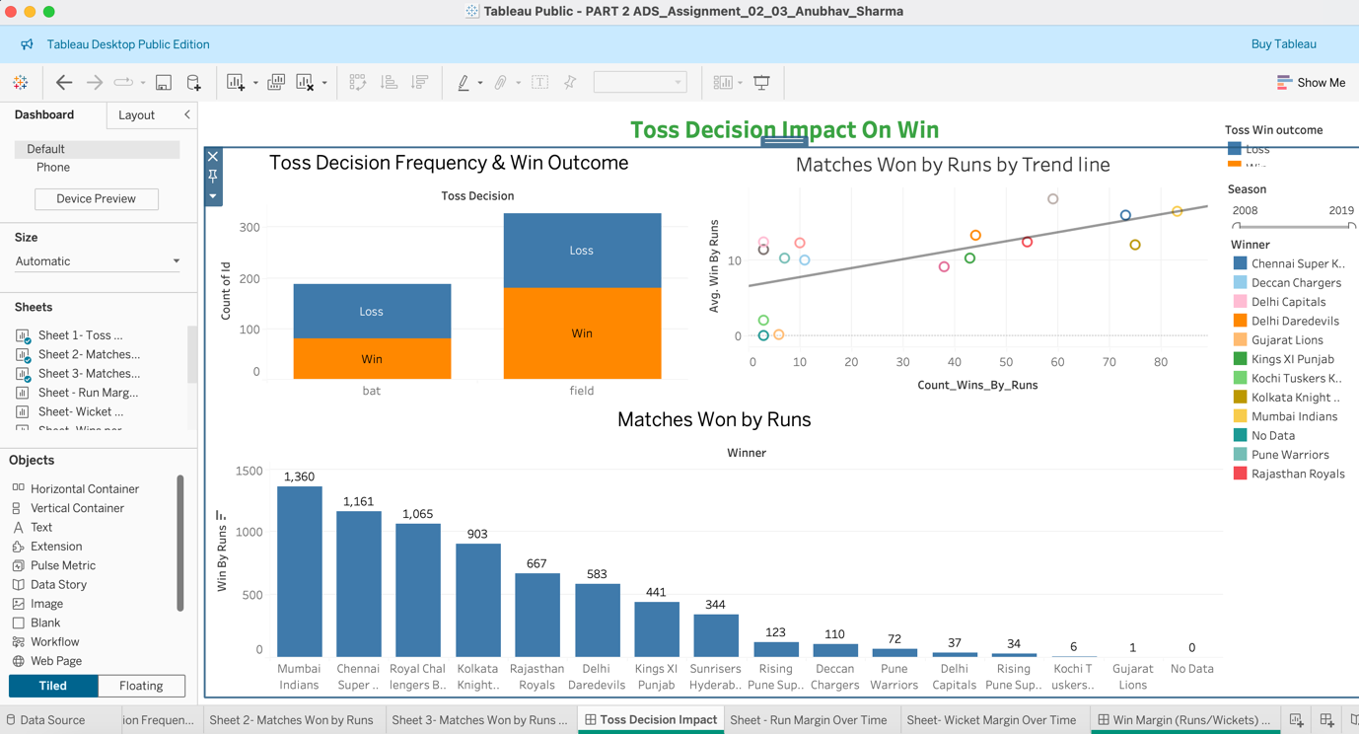

Dashboard 2: Win Margin (Runs/Wickets) Over Seasons

(Predictive Relationship: Win Margin vs Seasons)

- Created Sheet 1: Run Margin Over Time

- Dragged season to columns.
- Dragged Win by Runs to rows.
- And used Win by Run as average.
- Used Line Chart for visualization.
- Added Trend Line to show the relationship.

- Created Sheet 2: Wicket Margin Over Time

- Duplicate the sheet 1.
- Replaced Win by Runs with Win by Wickets.
- To get insights of how win margins have evolved across the years.
- Added season as filter.

Dashboard 2 Insights:

Target Audience:
IPL analysts, broadcasters.

Purpose:
To track how win margins have evolved across seasons.

Insights & Action:
Can guide predictions about future match competitiveness or performance.

Improved Decision-Making:
Informs expectations about team dominance or increasing balance in matches.

Dashboard 2 Screenshot:

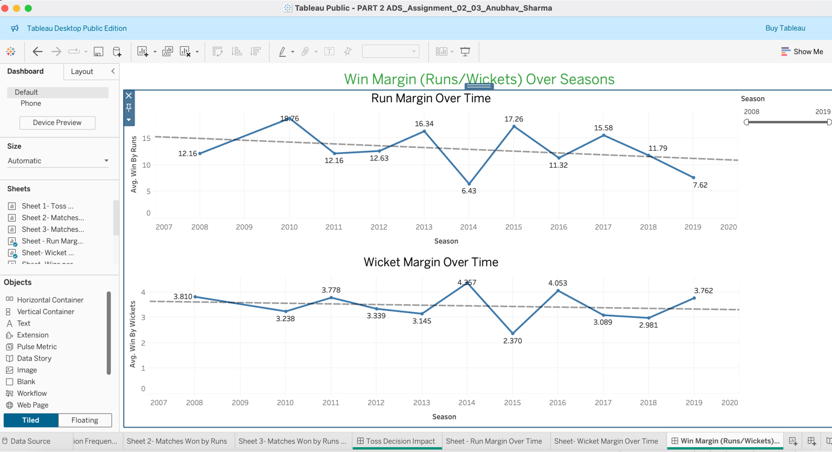

Dashboard 3: Winning Patterns of Teams Over Years

(Variable Relationship: Seasonal performance trends of teams using matches won.)

- Created Sheet 1: Wins per Season

- Dragged season to Columns.
- Dragged winner to Rows.
- Use count(winner) → Shows number of matches won per season.
- Convert to Line Chart.
- Added trend line.
- Added team filter to navigate teams separately or in combinations.

- Created Sheet 2: Team Consistency

- Use countd(season) per team → Number of seasons team appeared.
- Compare with count(winner) to measure consistency.
- Create calculated field: [Win Consistency % = count(winner) / countd(season)] and dragged this in rows.
- Used Bar Chart for visualization.

Dashboard 3 Insights:

Target Audience:
IPL Team management.

Purpose:
Track team’s long-term performance.

Insights & Action:
Identify most consistent teams and performance drops.

Improved Decision-Making:
Enables focus on sustained performance metrics.

Dashboard 3 Screenshot:

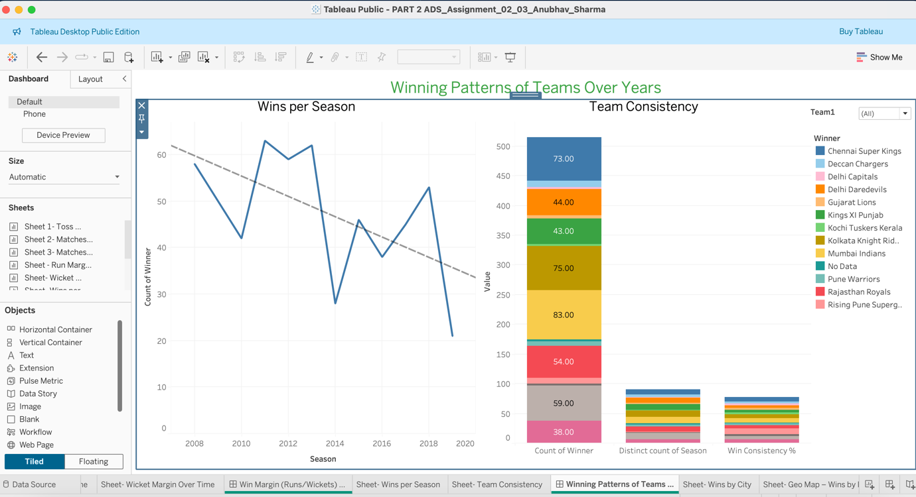

Dashboard 4: Top Performers in Cities and Stadiums

(Variable Relationship: City / Venue vs Winning Teams).

- Created Sheet 1: Wins by City

- Dragged city to Columns.
- Dragged winner to Rows.
- Set measure to count(winner).
- Color by winner, used stacked Bar Chart for visualization.
- Add filter for season.

- Created Sheet 2: Geo Map – Wins by Location

- Dragged city and Venue to Details.
- Dragged count(winner) to Size.
- I have used Map Chart → Geo Bubble for visualization.
- Colour by winner.
- Added filter for winner as single value dropdown.
- I was getting some issue due to unmatched locations so I have fixed those by manual filtering and then it is working fine.

Dashboard 4 Insights:

Target Audience:
Strategic planners, venue analysts.

Purpose:
To understand where teams perform best.

Insights & Action:
Teams can adjust strategies in favorable/unfavorable locations.

Improved Decision-Making:
Helps optimize performance and ticketing strategies based on city-based strengths.

Dashboard 4 Screenshot:

